

MGEC Executive Board Candidate Information
2024-2025 Term

Office you are running for
Director |  |  | Secretary |  |  | Vice President | X

Name: Corey Mathisen
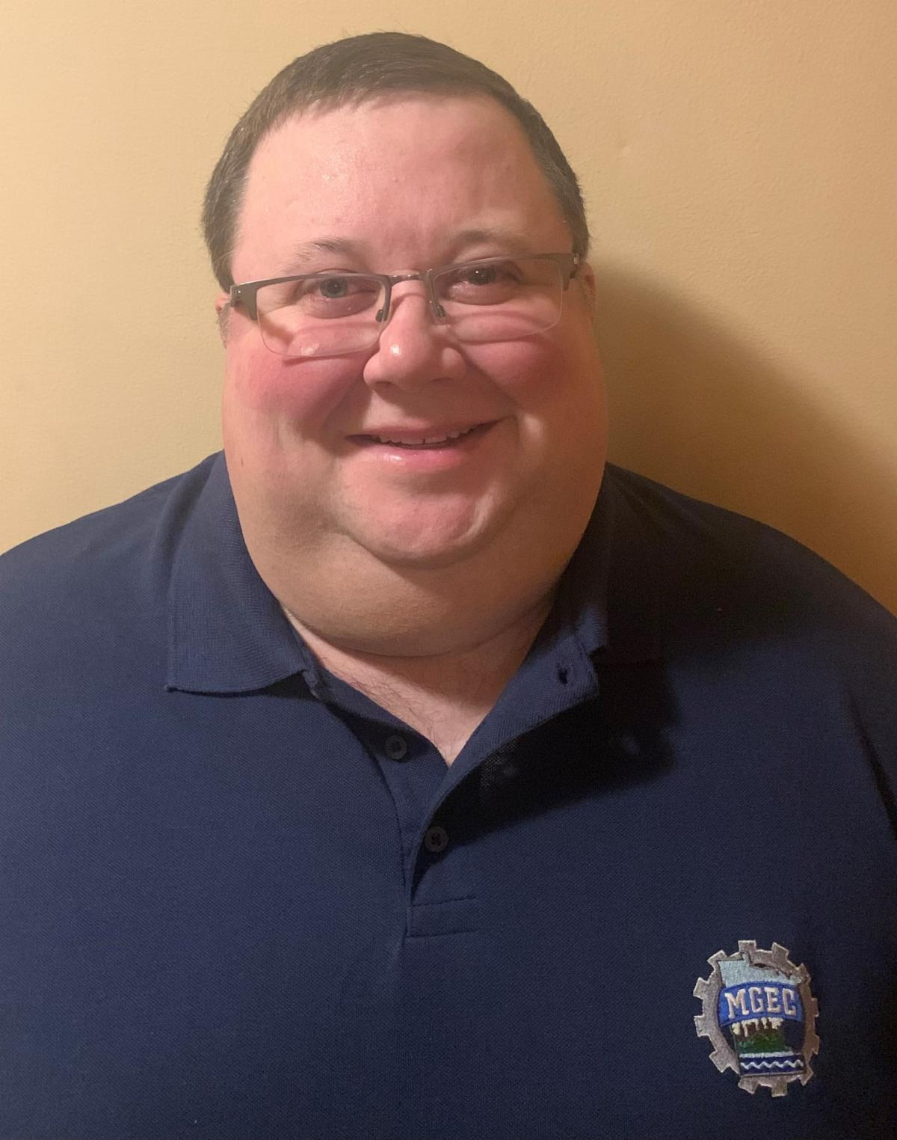

Job Classification: Principal Engineer

Current Agency/Office you work in: MDH (Health)/St. Paul

Work Address: St. Paul, MN Work Phone: 651-201-4494

Email: corey.mathisen@state.mn.us

Professional Licenses: PE

Previous/Current offices held with MGEC (list years) | Board Member | X | 5 years | Officer | X | Past Pres.
Previous/Current offices held with MGEC (list years) | Negotiations | X | Twice | Committee Member | X | Several
Previous/Current offices held with MGEC (list years) | Contact person | X | Several years | Instructor | X | Several

Number of years working for the State | 16 | Number of years a full MGEC member | 16

Why are you running an MGEC office?
I’m not trying to run an MGEC office, I’m just running for Vice President 😊 I bet you didn’t catch that typo on the form! Now that I have your attention, let me tell you why you should vote for me!

I will make sure MGEC represents ALL agencies and ALL classifications! MGEC needs good leadership for the next couple of years and I can provide it. Having served as President in 2022, I learned so many things and helped create a better MGEC for all members. That experience will allow me to hit the ground running as your future VP. During my presidency, I helped make MGEC a more transparent organization. I created the quarterly Meet with MGEC meetings to provide routine updates to all members. We started the Welcome to MGEC meetings which are tailored to new hires to help them learn about MGEC. Our budget needs to become more balanced. I want to be a good steward for our finances because it’s our members who fund this organization! I want to help MGEC be better. We need to find ways to reach our members to show them the value of MGEC. We need to find a way to better negotiate our contract with the state. I have ideas for improving MGEC and would be honored to receive your vote to help make this a better organization for YOU!

Additional information you want to share with members:
I live in Rosemount with my wife and 2 dogs. I’m a long-suffering Minnesota sports fan hoping for a championship of some kind…someday….I was actually alive for the Twins World Series wins but was pretty young so I don’t have good memories of them. I’m also a diehard Gopher and support all University of Minnesota teams and you can find me at Gopher football games on Saturdays in the fall. I’m the president of our weekly golf league. If I’m not at a sporting event, I’m probably organizing a neighborhood gathering in our driveway!

